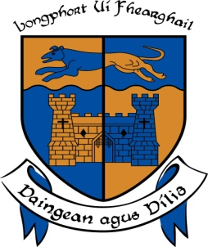

**LONGFORD COUNTY COUNCIL**

**COMHAIRLE CHONTAE AN LONGFOIRT**

**Minutes of April Monthly Meeting of Longford County Council**

**held in the Council Chamber, Aras an Chontae, Great Water Street, Longford on**

**Wednesday, 8th April 2015 at 4.00 p.m.**

**_______________________________________________________________________**

**PRESIDING**: Councillor Mark Casey, Cathaoirleach.

**MEMBERS PRESENT**: Councillors – John Browne, John Duffy, Seamus Butler,

Mick Cahill, Micheál Carrigy, Gerard Farrell,

Padraig Loughrey, Martin Mulleady, Colm Murray,

Pat O’Toole, Peggy Nolan, P.J. Reilly, Paul Ross,

Mae Sexton and Gerry Warnock.

**IN ATTENDANCE:**  Mr. Tim Caffrey, Chief Executive.

Mr. Frank Sheridan, Director of Services.

Mr. Barry Lynch, Director of Services/Head of Finance.

Mr. Tom Murtagh, Acting Director of Services.

**MEETINGS**

**ADMINISTRATOR**: Ms. Anne Lee.

**VOTE OF SYMPATHY.**

On the proposal of M. Carrigy seconded by Councillor S. Butler, it was unanimously resolved that a vote of sympathy be extended to Councillor Paraic Brady and the Brady family on the death of his Mother, Elizabeth and that the meeting be adjourned as a mark of respect.

Councillor Carrigy also requested the members to keep Gerry Brady in their thoughts and prayers during his current illness.

It was agreed that theAdjourned Meeting take place on Wednesday, 15th April 2015

at 4.00 p.m.

**This concluded the business of the meeting.**

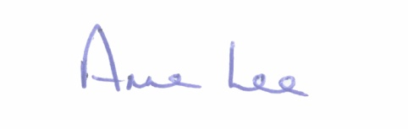

**Signed: _______________**

**Anne Lee,**

**Meetings Administrator.**

**Confirmed and adopted at Monthly Meeting of Longford County Council held on the**

**13th May 2015.**

**Signed: _______________**

**Cathaoirleach.**